**Topics: Descriptive Statistics and Probability**

1. Look at the data given below. Plot the data, find the outliers and find out $μ, σ, σ^{2}$

|  |  |
| --- | --- |
| **Name of company** | **Measure X** |
| Allied Signal | 24.23% |
| Bankers Trust | 25.53% |
| General Mills | 25.41% |
| ITT Industries | 24.14% |
| J.P.Morgan & Co. | 29.62% |
| Lehman Brothers | 28.25% |
| Marriott | 25.81% |
| MCI | 24.39% |
| Merrill Lynch | 40.26% |
| Microsoft | 32.95% |
| Morgan Stanley | 91.36% |
| Sun Microsystems | 25.99% |
| Travelers | 39.42% |
| US Airways | 26.71% |
| Warner-Lambert | 35.00% |

For Given Dataset :-

1)Mean=33.27

2)Variance=287.14

3)Standard Deviation=16.94

-Outlier For Given Dataset is 91.36

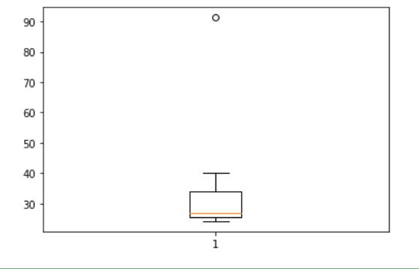



Answer the following three questions based on the box-plot above.

1. What is inter-quartile range of this dataset? (please approximate the numbers) In one line, explain what this value implies.

Ans:-IQR(Inter Quartile Range)=Upper Quartile-Lower Quartile

IQR=12-5=7

IQR=Middle Half Of The Data Set Falls In The I.Q.R.

1. What can we say about the skewness of this dataset?

ANS:-Since Median<Mean So It Is Right Skewed Data

1. If it was found that the data point with the value 25 is actually 2.5, how would the new box-plot be affected?

ANS:-Then We Can Say In The Boxplot Have No Outlier Is Present.



Answer the following three questions based on the histogram above.

1. Where would the mode of this dataset lie?

ANS:- Mode Of The Data set Lie In-between 4 To 10

1. Comment on the skewness of the dataset.

ANS:-Skewness Of The Dataset Is Right Skewed Data

1. Suppose that the above histogram and the box-plot in question 2 are plotted for the same dataset. Explain how these graphs complement each other in providing information about any dataset.

ANS:-

By Plotting Histogram and boxplot we can Find Skewness Of The Dataset

i)By using histogram we can see clearly Distribution Of the Data

ii)By Using Boxplot We Can Detect Outlier For The Data set

1. AT&T was running commercials in 1990 aimed at luring back customers who had switched to one of the other long-distance phone service providers. One such commercial shows a businessman trying to reach Phoenix and mistakenly getting Fiji, where a half-naked native on a beach responds incomprehensibly in Polynesian. When asked about this advertisement, AT&T admitted that the portrayed incident did not actually take place but added that this was an enactment of something that “could happen.” Suppose that one in 200 long-distance telephone calls is misdirected. What is the probability that at least one in five attempted telephone calls reaches the wrong number? (Assume independence of attempts.)

ANS:-

A:-The Call Is Misdirected

Then Probab. Of Event(A) is

P(A)=1/200

Probablity That at least Out Of 5calls 1 call reached the wrong Number

=1-Probablity that no attempted call reaches the wrong Number

=1-P(A bar)

=1-(199/200)*(199/200)*(199/200)*(199/200)*(199/200)

=0.025

Then Probablity For Out Of 5calls ->1calls Reaches The Wrong Number is=0.025

1. Returns on a certain business venture, to the nearest $1,000, are known to follow the following probability distribution

|  |  |
| --- | --- |
| x | P(x) |
| -2,000 | 0.1 |
| -1,000 | 0.1 |
| 0 | 0.2 |
| 1000 | 0.2 |
| 2000 | 0.3 |
| 3000 | 0.1 |

1. What is the most likely monetary outcome of the business venture?

Maximum P(x)-0.3 .So Most Likely Monetary Outcome Of the Buisness Venture is 2000

1. Is the venture likely to be successful? Explain

P(x)=-0.1-0.1+0.2+0.2+0.3+0.1=+0.6. Which Indicates That There is 60% Probability That The Venture Likely To Be Successful.

1. What is the long-term average earning of business ventures of this kind? Explain

Long-term Average Earning Of Business Venture =

=(-2000*1)+(-1000*1)+(0*2)+(1000*2)+(2000*3)+(3000*1)

=8000/6=1333

1. What is the good measure of the risk involved in a venture of this kind? Compute this measure

ANS:-Here There is 60% Probability For Profit And There is 20% Probability For Loss

Positive Return Is More Than the Negative Return =60% > 20%.So we can say No risk

Involved.